[www.codly.in](http://www.codly.in/)

+91 93 1582 1186

[contact@codly.in](mailto:contact@codly.in) 1095-A GF, Kamrangaguri, Dabgram(P), Fulbari Hat, Rajganj, Jalpaiguri- 734015, West Bengal

**To:**

INTERNSHIP OFFER LETTER

Jan 29, 2026

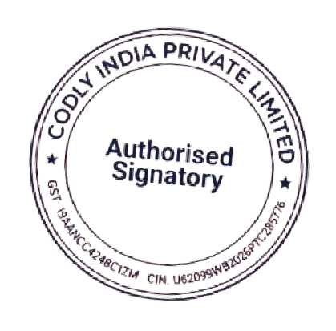Aman Gupta S/o Sushil Kumar Gupta Dhalwala, Rishikesh,



**Internship Duration:** 3 Months

**Stipend: Rs.** 4,000 /- P.M

**Performance & Future Employment:**

Upon successful completion of the internship and subject to satisfactory performance, you may be considered for full-time employment with Codly India Private Limited.

**Acceptance:** Please confirm your acceptance of this offer by replying to this email with

“I accept the Internship Offer”.

**Sincerely,**

**Aditya Kushwaha Director & HR**

Uttarakhand – 249137

# Dear Aman Gupta,

We are pleased to offer you an internship at Codly India Private Limited for the position of Software Developer Intern in the Engineering Department.

# Internship Details:

**Internship role:** Software Developer Intern **Department:** Engineering Department **Employment Type :** Internship Full- time **Working Mode:** Remote